|  |  |  |
| --- | --- | --- |
| **Tech Saksham**  Final Project Report  **Track Name** |  |  |

**“Project Name”**

**Hotel Reservation System**

**“College Name”**

**Avanthi’s Scientific Technological And Research Academy**

|  |  |
| --- | --- |
| **ROLL NO** | **NAME** |
| 19PT1A0514 | J.Divya |
| 19PT1A0541 | G.Gayathri |
| 19PT1A0555 | T.Jahnavi |
| 19PT1A0512 | G.Manasa |

|  |  |
| --- | --- |
|  | Trainer Name |
|  | Uma Maheswari |
|  |  |

**ABSTRACT**

Hotel reservation system is an important part in the life of a modern hotel, because it ensures proper work of the hotel, making it efficient and provides the option to book a room online. It holds information for the workers and administration about the rooms and the hotel overall. This system removes most of the paperwork making it an obligatory asset to have for every modern hotel. Analyses and improves the current reservation system. The aim of this work is to provide in-depth analysis about the system. Search of theory, regarding hotels, reservations, online reservations and online reservation systems. Attempt to improve the current situation in hotel reservation business. Also to create a small prototype, showing how the system will work from the user side. A hotel reservation system is a piece of software that allows clients to book directly with the hotel online, by passing the need for middlemen. It enables guests to design their vacation at their leisure. It’s a software application that shows your live pricing and inventory across all of your channels in real-time, allowing guests to choose their dates and complete their reservations.

**INDEX**

|  |  |  |
| --- | --- | --- |
| **Sr. No.** | **Table of Contents** | **Page No.** |
| 1 | Chapter 1: Introduction | 1 |
| 2 | Chapter 2: Services and Tools Required | 4 |
| 3 | Chapter 3: Project Architecture | 7 |
| 4 | Chapter 4: Architecture Blocks Detail Working | 8 |
| 5 | Chapter 5: Project Budget | 10 |
| 6 | Conclusion | 11 |
| 7 | References | 12 |
| 8 | Code | 14 |

**1.INTRODUCTION**

**Purpose**

The main purpose of this project is to book the rooms in the hotels, which are registered with the application. With this application the customers no need to visit the hotels physically they can directly book rooms online.

**1.1.OVERVIEW**

**Software Architecture**

The architecture of a system describes its major components, their relationships (structures), and how they interact with each other. Software architecture and design includes several contributory factors such as Business strategy, quality attributes, human dynamics, design, and IT environment. 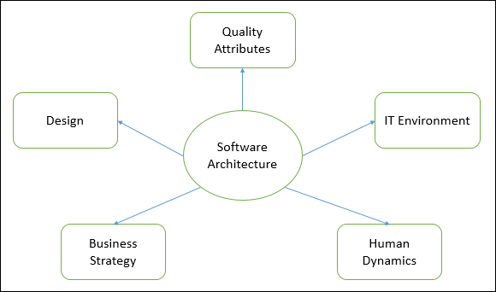We can segregate Software Architecture and Design into two distinct phases: Software Architecture and Software Design. In **Architecture**, nonfunctional decisions are cast and separated by the functional requirements. In Design, functional requirements are accomplished.

**1.2 Features**

### **1. Straightforward management of reservations**

### **2. Ability to manage group bookings**

### **3. Easy management of room assignments**

### **4. Mobile-friendly**

### **5. Automation**

### **6. Easy inventory management**

### **7. Intuitiveness and ease of set-up**

**1.3 Advantages**

### 1. Save time on admin tasks

### 2. Develop strong relationships with your guests

### 3. Increase your online visibility

### 4. Implement an effective revenue management system

### 5. Manage distribution functions

### 6. Increase bookings

**1.4 Scope**

A hotel reservation system is software used in the hotel industry to manage room inventory, rates, and bookings. Also called a central reservations system (CRS), it may be housed within the hotel’s property management system (PMS) or may be standalone software connected to the PMS.

### ****1.5 Future Works****

### ****Cloudbeds.****

Cloudbeds provides a cloud-based, fully integrated hospitality management platform with all the tools you need to ensure a seamless reservation process. See the section below for more information.

### ****RMS Cloud.****

RMS Cloud features an integrated PMS, booking engine, channel manager, and revenue management system suitable for all types of lodging operators.

### ****Frontdesk Anywhere.****

Frontdesk Anywhere is a cloud-based hotel management software with an integrated PMS, channel manager, booking engine, and revenue management system built for independent hotels and management groups

2. Platforms with a PMS + booking engine

### ****Mews.****

Based in Prague, Mews is a cloud-based PMS system that offers integrated operations, payments, guest journey, BI, Marketplace, and API solutions.

### ****Protel.****

Based in Germany, Protel is a legacy PMS provider that also offers a website booking engine, mobile app, and events software.

### ****Resnexus.****

Based in the United States, Resnexus is a cloud-based PMS popular with bed & breakfasts and inns that offer a website and booking engine along with guest management, credit card processing, and automatic yield management.

3. Central reservation systems + booking engine

**2.1 Services used**

This project discussed the tool and technology used in developing the proposed system (the system has a front end by using html, Css, JavaScript to display the content structure and a back end of database using MySQL and PHP). Two online reservation systems were compared to identify their similarities and differences.

**2.2 Liberty Profile**

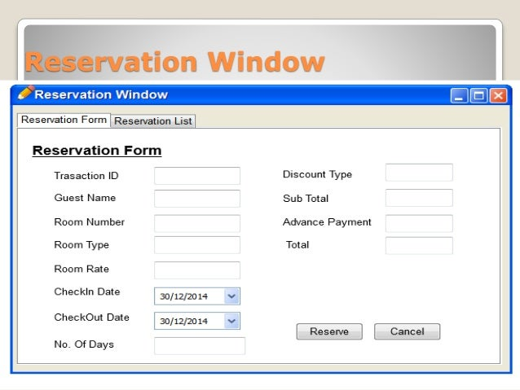

**2.3 Tools and Software used**

Below you’ll find ten top hotel management software tools that are revolutionizing how hotels operate. Many hotels use this brainchild of eZee Technosys for hotel reservations, rate management, revenue maximization, and event management. In fact, EZee Frontdesk is rated among the fastest growing softwares in the property management realm.

Best Hotel booking software are StayFlexi, Sirvoy, Little Hotelier, Cloud Hotel ERP, and NOBEDS. With a user-friendly interface and easy navigation, these hotel booking software systems will help you reduce manual effort

**PROJECT ARCHITECTURE**

**3.1 Architecture**

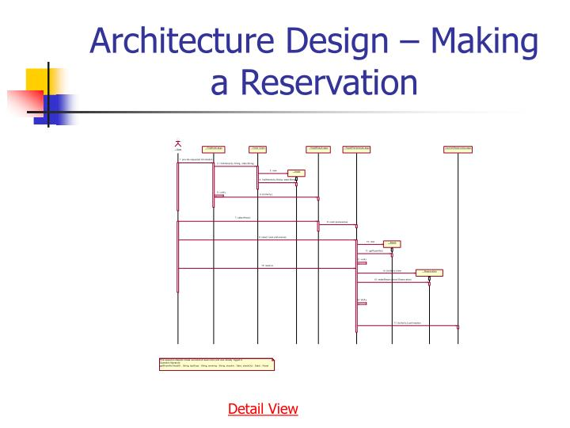

**ARCHITECTURE BLOCKS DETAIL WORKING**

This is the service that will be given to hotel managers/owners. In this managers can manage their hotel's related information. Here managers have a separate portal to access the data and update it.

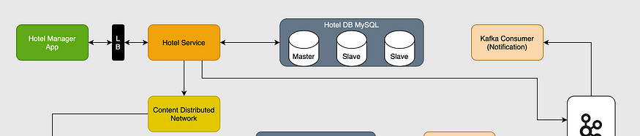

Hotel Management Service Architecture

Whenever an API is triggered from the hotel manager app the initial request is been sent to the load balancer, then the load balancer distributes the requests to the desired server to process. The hotel service cluster has multiple servers that have the container for hotel service-related API.

Now, this hotel service interacts with the Hotel DB cluster which follows the master-slave architecture to reduce the load in the database. Basically, in this approach, we create a replica of the master database which are called a slave database. Master DB is used for a write operation and slave DB is used for reading operation only. Whenever a write operation is performed on the master database it syncs the data to the slave database.

Whenever any data is updated in the database API sends the data to the CDN(Content Distributed Network) and to a Messaging Queue System(like Kafka, RabbitMQ) for further processing. A CDN is a geographically distributed group of servers that work together to provide fast delivery of Internet content.

# **Customer Service (Search + Booking)**

This is the service that will be given to customers. In this customers can search and book a hotel. Here customers have a separate portal to access the data and process it.

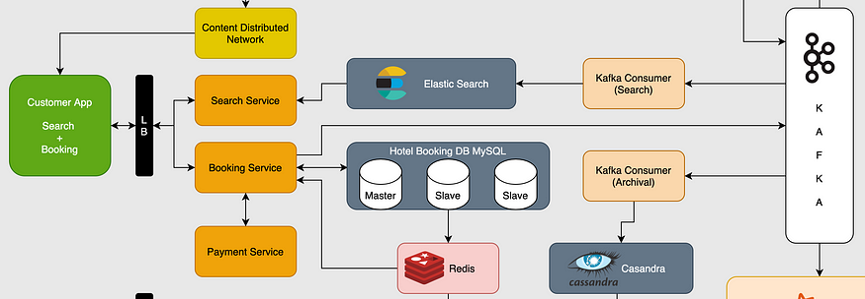

Customer Service Architecture

**CONCLUSION**

* While developing this project we have learnt a lot about hotel management.
* The Online Hotel Reservation System was developed to replace the manual process of booking for a hotel room or any other facility of development
* The old system does not serve the customer in a better way rather it makes customer data vulnerable.
* The new system keeps proper records of customers for emergency and security purposes.
* We have learnt how to make a system user friendly.
* During the development process we studied carefully and understood the criteria of implementation process.

**REFERENCES**

[1] B.S. Afriyie, Concise ICT Fundamentals Volume One, Trafford Publishing, 2012.

[2] T. Berners-Lee, Web Design Issues, 1998, http://www.w3.org/DesignIssues/RDFnot.html.

[3] H. Bidgoli, Essentials of Software Engineering 2011.

[4] V. DeBolt, Mastering Integrating Html and CSS, ISBN: 978-0-470-09754-0, 2007

[5] P. Ghosh, SQL Popcorn, Eastern Economy ed, New Delhi : PHI Learning, 2010.

[6] R. Malloy, Internet and Personal Computing Abstracts: IPCA, Volume 22 Issues, Information Today, Incorporated, 2001, 2001.

[7] D.S. McFarland, Dreamweaver CS4: The Missing Manual. O’Reilly Media Inc, 2008.

[8] J. Pan, S. Chen, and N. Nguyen, Intelligent Information and Database Systems: 4th Asian Conference, ACIIDS, Proceedings Part 2, Kaohsiung, Taiwan, 2012.

[9] N. Sfetcu, Web Design & Development, 2014.

[10] M. Taylor, A General Understanding of Microsoft Excel, Visual Studio and Webmatrix2, Mark Taylor and Paragon Publishing, Rothersthorpe, 2013.

[11] http://533507.weebly.com/notepad.html, Accessed on 15/11/14.

[12] https://adroitcare.wordpress.com/tag/microsoft-windows-operating-system/, Accessed on 15/11/14.

[13] http://lamp.cse.fau.edu/~knagarsh/html.html, Accessed on 15/11/2014.

[14] http://www.w3schools.com/html/html_intro.asp, Accessed on 15/11/14.

[15] http://www.mindspeakit.com/web-development-2/products/hotel-management-system/, Accessed on 15/11/14.

[16] https://lib.fsu.edu/adobe-dreamweaver, Accessed on 15/11/14.

[17] http://techstream.org/DIY/wamp_server_config, Accessed on 15/11/14.

[18] http://www.marolinedesign.com/tutorial-topics/wamp/ , Accessed on 15/11/14.

[19] http://www.shangri-la.com/singapore/shangrila, Accessed on 15/12/12.

[20] http://www.swissgarden.net/, Accessed on 15/12/12.

[21] http://www.hansbotelghana.com/, Accessed on 15/11/12.;

[22] www.hansonichotel.com, Accessed on 15/12/12.

[23] www.hotelbookers.com, Accessed on 15/12/12.

**CODE**

**Please Provide Code through Git Hub Repo Link**

**https://github.com/divyasrinivas3/Hotel-Reservation-system.git**